Big Data and Biology
Michael Fang

Introduction:
Big Data is a fairly hot buzzword these days, particularly with regard to the use of computational algorithms to sort through difficult problems in biology that would otherwise be extremely difficult or even impossible to parse through. But what does Big Data actually entail in biology? Here we present two views on the subject, one from a big picture, historical perspective, and one on a smaller scale, to illuminate how big data algorithms actually work.

Analysis:
Perhaps the most prevalent and researched use of Big Data is in the bioinformatics of genetics. The basic idea is quite simple: an organism’s genome consists of a set of nucleic acids in a particular sequence which code for proteins. In humans we have about 3.23 billion bases, and about 19,000 to 20,000 protein-encoding genes (Ezkurdia et al., 2014). Because many medical issues are the result of misfolding or loss of particular bases in those protein-encoding genes, being able to scan through multiple people’s genomes to compare differences seems like a good way to isolate problem genes.

The first human genome was sequenced in 2001 (Sequencing Consortium) and sequencing time and costs have dropped exponentially since then. From a computer science perspective, searching through 3.23 billion variables that only have 4 possible values is, while not trivial, not a particularly difficult task, especially when 99.9% of the sequence is identical for most humans (Abecasis, 2012). So why then, are we still unable to determine specific genetic causes for many diseases that are clearly genetic in origin?

The answer is that the genome is much more complicated than it first appears. The vast majority of the 3.23 billion base-pairs do not code for any protein (only about 60,000 bases, or 0.0018% of the genome code for proteins). But that does not mean they have no functionality (though some do not); they are involved in how a gene is expressed (timing, quantity, duration), the regulation of expression, and associated signals. Moreover the genome is a physical object and not just an abstract, linked-list of data, so it must obey physics, and the literal, physical curvature of the genome itself can effect how these genes are expressed.

For example, the RNA codon (via transcription from genes) sequence 1-AUG GCC GGA UGG CUA CCC UAG codes for Methionine (initiation), Alanine, Glycine, Tryptophan, Leucine, Proline, Stop (Amber). However, if, for example, there is a frameshift mutation, where the first adenine is missed, the ribosome would skip past the uracil, glycine, glycine, cytosine… all the way to the 9th base in the sequence, which has an out-of-frame AUG. This Start sequence then reads (A)-UGGCCGG AUG GCU ACC CUA G…, which decodes as Methionine (initiation), Alanine, Threonine, Leucine. This is a completely different sequence, which likely does not encode a protein (in other words, a “nonsense” string), but may in fact produce a protein (“sense” string).

(There are additional complications on top of the simplified explanation above, such as a programmed translational frameshift. A more extensive explanation is beyond the scope of this paper).

This increased complexity means that algorithms to determine mutations in particular sequences must test for variances in each position, compared to every variance in the position of an opposing sequence. Time complexity, as categorizes by Big-O notation, shows this difficulty. Whereas algorithms of O(n^2) are already seen as slow (bubble sort, insertion sort), genetic sequencing is significantly slower, taking exponential time of O(2^n), or generally 2 ^ poly(n).

Table of common time complexities:
Name | Running Time (T(n)) | Example algorithms
Constant time | O(1) | Array accessing time
Logarithmic | O(log n) | Binary Search
Linear time | O(n) | Finding largest or smallest item in unsorted array
Quasilinear | O(n log n) | Best case for comparison sort
Quadratic | O(n^2) | Bubble sort, Insertion sort
Cubic | O(n^3)
Polynomial | 2^ O(log n)
Exponential | 2^ O(n) | SNP comparisons

Given these problems, how does Big Data help? Presently, scientists ignore many of the wider problems to concentrate on smaller subsets of data. For instance, if a scientist suspects that a particular gene is the cause of a disease (a so-called Single Nucleotide Polymorphism), then he or she may probe for the many millions of variations of that particular genetic variant (Chan, 2012). Retrieval trees, sequences and string algorithms, in particular, are quite important in this venture.
Findings:
To see how this might work, let us look at a smaller data-set: mine. Between 2014 and 2015 I was a member of a research team at the New Jersey Medical School, where we were interested in a possible novel use of a combination of drugs to treat leukemia cancers.

Problem: averages obscure information about individual cell differences

Our first problem was rudimentary: how do we know that the drug combination was working? A simple dye (Trypan Blue) to stain dead cells was used, and cells were counted, by eye, using a microscope and a hemocytometer, a simple piece of glass with known distances etched onto its surface. This kind of data collection is not a particularly reliable system. Not only is the work mind-numbing and thus particularly prone to human error, but it is also very slow; even if someone was counting three or four cells per second, it would still take hours to finish just 8 or 16 samples.

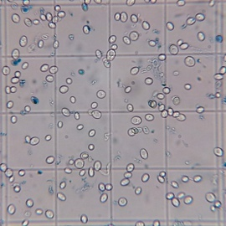

Example of Trypan Blue staining: Trypan Blue is a dye that selectively colors dead cells. Because cells are extremely selective about what compounds are allowed to pass through their membrane, live cells will not be stained. This 4x4 field showing promyeolytic leukemia HL60 cell-line cells has 4 ‘dead’ cells (fully apoptotic), 2 early apoptosis, and fragments, along with 117 live cells, or about a 98% survival (viability) ratio, which is roughly normal for this cell line under optimal culture and perfusion conditions.

So humans are slow and prone to making mistakes. Automation, hypothetically, would solve many of these problems. However, until recently, algorithms for differentiating between cells lagged behind the expertise of a trained eye, and thus many labs, including the one I worked in, still relied heavily on the free labor of graduate students to manually count thousands of cells by eye.

How then, does big data allow researchers to refine these algorithms?

The answer is Flow Cytometry. Flow cytometry offers a way of quickly scanning an enormous number of cells very quickly in order to obtain statistically relevant data sets.

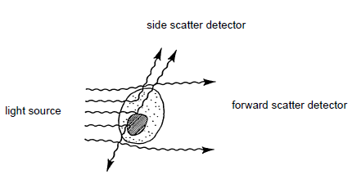
(BD Biosciences)

In Flow Cytometry, cells are aligned and passed, single-file, through a narrow channel. A series of parallel laser beams scatter off of the cell, and, reports on how much diffracted light is detected just off the incident axis (forward scatter) and how much light is reflected (side-scatter). Forward scatter is proportional to the cell’s surface area and thus size, whereas side-scatter is proportional to the amount of internal complexity or granularity in the cell. By these two datum, we can construct a distribution of cells in a sample, and compare multiple samples, often by inspection.

Even as recently as 2013, the vast majority of flow-cytometry algorithms were manually, and often arbitrarily, selected (Aghaeepour et al., 2014). This was not necessarily due to negligence or user bias (although it is a very human problem in science), but was borne out of the experience and experimentation that these scientists had available to them.

For example, clustering F-measure is dependent on precision (how often a particular reference method was replicable), and recall (true positive/(true positive + false positive)).
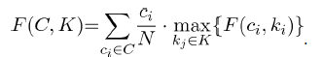

This provides a measure of data set reliability based on existing models. As Aghaeepour showed, this type of clustering can be mapped into some form of consensus model, dependent on data extracted from multiple models. In this sense, a computational model could inform the ‘correctness’ of any particular model.

I applied a fairly simplified version of this model to the data I obtained from my time at NJMS. Importantly, while this data was collected in 2014-2015, no complete analysis across all experiments was done on it at the time. In total, 24 of 26 experiments conducted in this period were included (2 had settings which were not appropriate to the data set). The data is presented below.

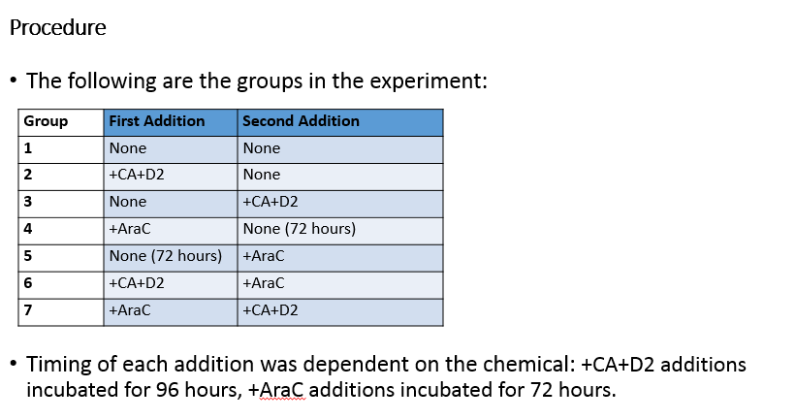
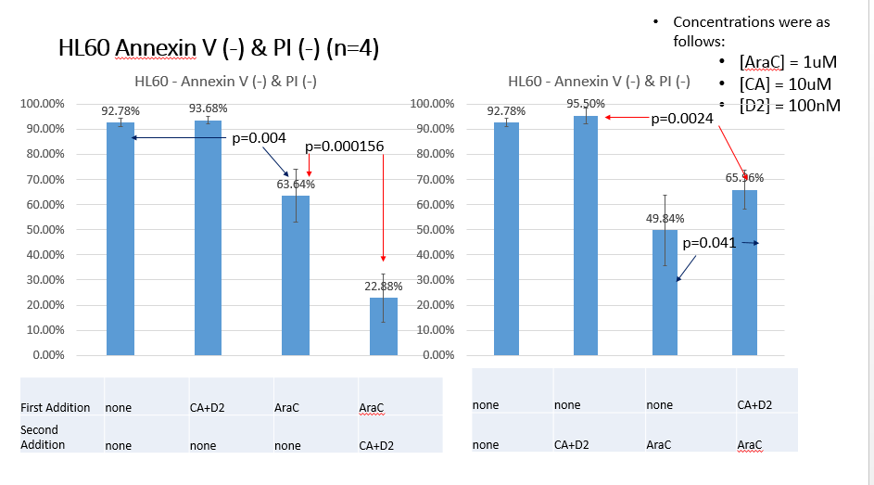

Conclusion:
The actual data is not particularly important to the discussion with regards to computer science. Rather, it is the fact that vast number of cells can be counted to produce statistically significant data in the first place. This can be through the painstaking process of protein comparison calculations, or through simpler methods such as flow cytometry, each fit for a different purpose.

Appendix:
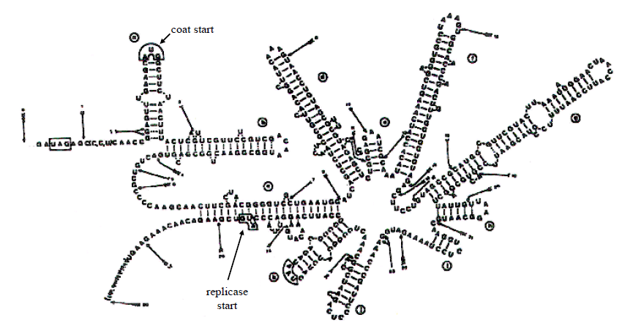
The above picture shows that DNA sequences are not just a list of data: they are a physical entity, beholden to the laws of physics, and the particular sequence of a non-sense piece of code tens of thousands of base-pairs away from the gene in question may end up regulating the expression of our gene, simply because of the way it folds. Elegant and powerful.

Works Cited:

Abecasis GR, Auton A, Brooks LD, DePristo MA, Durbin RM, Handsaker RE, Kang HM, Marth GT, McVean GA (Nov 2012). "An integrated map of genetic variation from 1,092 human genomes". Nature. 491 (7422): 56–65. doi:10.1038/nature11632. PMC 3498066 . PMID 23128226.

Aghaeepour N, Finak G, FlowCAP Consortium., DREAM Consortium., Hoos H, Mosmann TR, Brinkman R, Gottardo R, Scheuermann RH
Nat Methods. 2013 Mar; 10(3):228-38.

https://www.ncbi.nlm.nih.gov/pubmed/23396282/ (link to above paper)

BD Bioscences. Introduction to Flow Cytometry: a Learning Guide. 2000. Becton, Dickson and Company.

Cliburn Chan (September 2012). Big data in computational biology. XRDS. ACM.

Michael Danilenko, Qing Wang, Xuening Wang, et al. Carnosic acid potentiates the antioxidant and prodifferentiation effects of 1alpha,25-dihydroxyvitamin D3 in leukemia cells but does not promote elevation of basal levels of intracellular calcium. Cancer Res. 2003 Mar 15;63(6):1325-32.

Ezkurdia I, Juan D, Rodriguez JM, Frankish A, Diekhans M, Harrow J, Vazquez J, Valencia A, Tress ML (November 2014). "Multiple evidence strands suggest that there may be as few as 19,000 human protein-coding genes". Human Molecular Genetics. 23 (22): 5866–78. doi:10.1093/hmg/ddu309. PMC 4204768 . PMID 24939910.

Goldman, E. Gene Expression (2015). Translational regulation of RNA and proteins.

Hu ZB, Yang GS, Li M, Miyamoto N, Minden MD, McCulloch EA. Mechanism of cytosine arabinoside toxicity to the blast cells of acute myeloblastic leukemia: involvement of free radicals. Leukemia 1995;9:789-98.

International Human Genome Sequencing Consortium Publishes Sequence and Analysis of the Human Genome.

